

经常会需要将数据从A 批次转移到B批次。

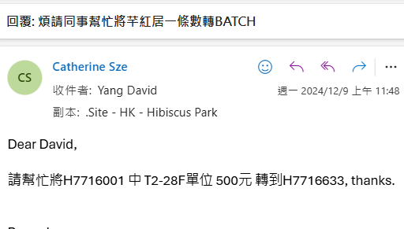

先搜索Batch里面的数据详细

|  |
| --- |
| select  (select count(*) from CMLEDG (nolock) where cmbatchid = cmbtch.cmbatchid) as CMLEDG  ,(select count(*) from cmledgapply (nolock) where tranid in (select tranid from cmledg where cmbatchid = cmbtch.cmbatchid)) as ledgapply_tranid_count  ,(select count(*) from cmledgapply (nolock) where ptranid in (select tranid from cmledg where cmbatchid = cmbtch.cmbatchid)) as ledgapply_ptranid_count  ,(select count(*) from cmbnont (nolock) where cmbatchid = cmbtch.cmbatchid) as cmbnont  ,(select count(*) from cmsdlg (nolock) where cmbatchid = cmbtch.cmbatchid) as cmsdlg  ,(select count(*) from cmrcpt (nolock) where cmbatchid = cmbtch.cmbatchid) as cmrcpt  ,(select count(*) from recpt (nolock) where cmbatchid = cmbtch.cmbatchid) as recpt  ,(select count(*) from cmmisc (nolock) where cmbatchid = cmbtch.cmbatchid) as cmmisc  ,(select count(*) from cmnont (nolock) where cmbatchid = cmbtch.cmbatchid) as cmnont  ,(select count(*) from CMDEPOSIT (nolock) where cmbatchid = cmbtch.cmbatchid) as CMDEPOSIT  ,(select count(*) from cmvoidreceipt (nolock) where cmbatchid = cmbtch.cmbatchid) as cmvoidreceipt  ,(select count(*) from CMSDADJ (nolock) where cmbatchid = cmbtch.cmbatchid) as CMSDADJ  ,cmbtch.*  from cmbtch  left join proj b on b.siteid = left(cmbtch.cmbatchid,2)  where cmbtch.cmbatchid IN ('W4720180') |

根据用户邮件描述的金额数据

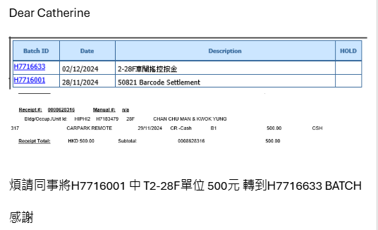

查找到对应的数据

select * from cmrcpt where cmbatchid = 'H7716001' and tranamt = 500

select * from recpt where cmbatchid = 'H7716001' and tranamt = 500

然后迁移到新的批次

update cmrcpt set cmbatchid = 'H7716633' where cmbatchid = 'H7716001' and tranamt = 500

update recpt set cmbatchid = 'H7716633' where cmbatchid = 'H7716001' and tranamt = 500